***Virginia Junior Classical League***

*presents this*

Certificate of Excellence

*to*

Nathan Radossevich

*of*

Blessed Sacrament Huguenot

*for*

*1st Place in Oil*

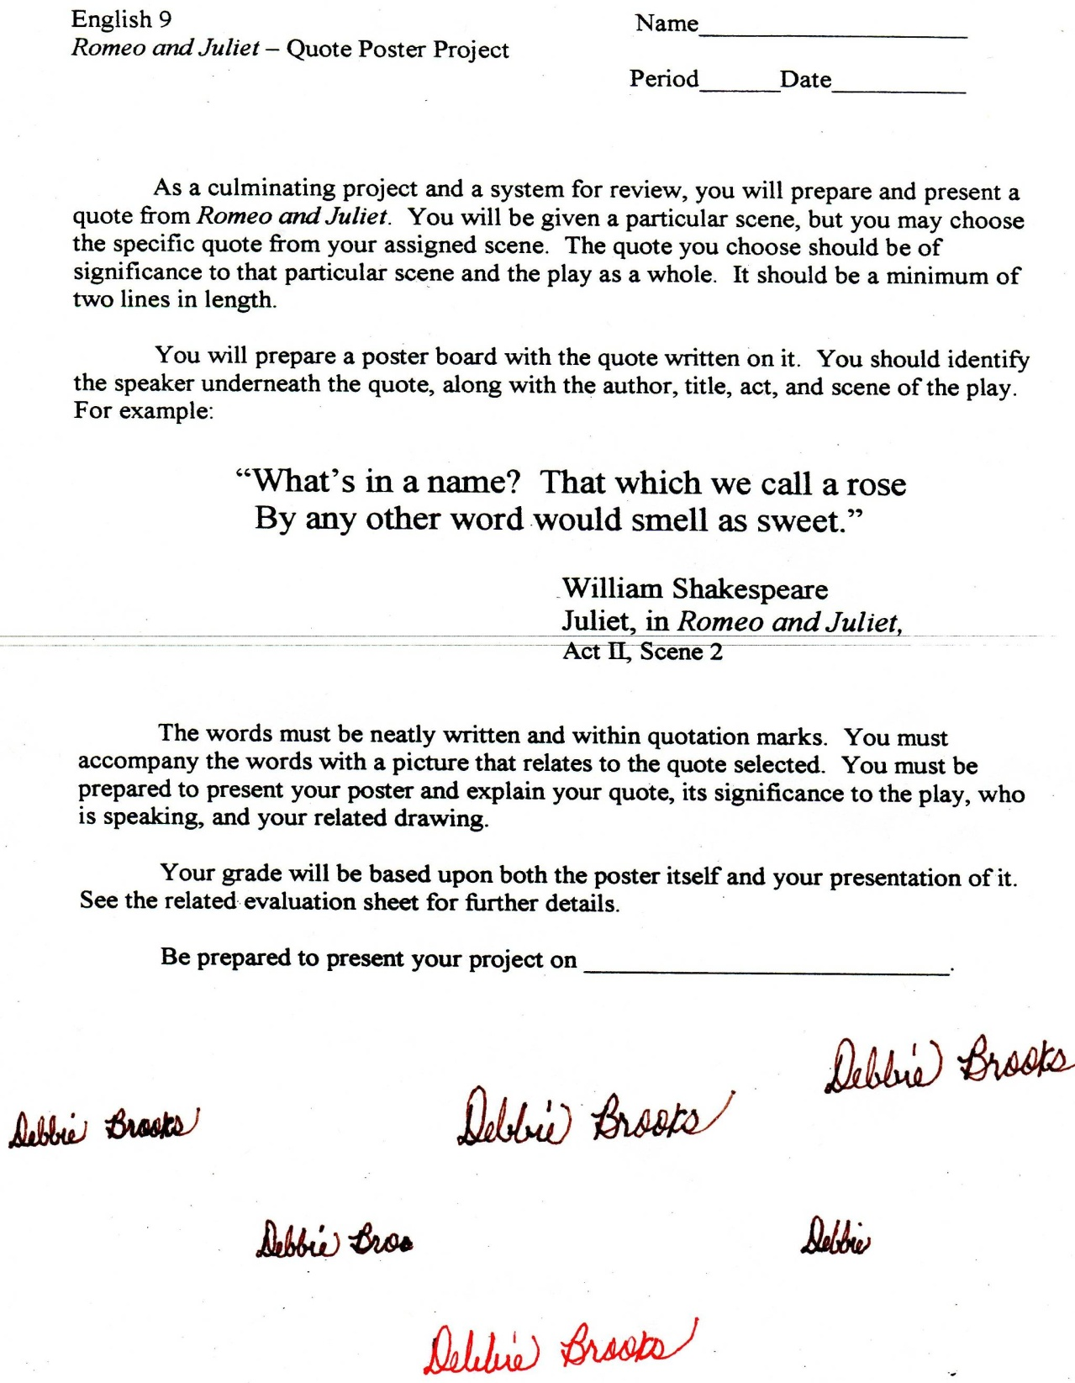

Microsoft Office Signature Line...

*a.d. viii Kal. Dec. MMDCCLXVII A.U.C. 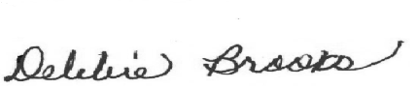*

***Virginia Junior Classical League***

*presents this*

Certificate of Excellence

*to*

Mckayla Roberts

*of*

Blessed Sacrament Huguenot

*for*

*3rd Place in Posters*

**

Microsoft Office Signature Line...

*a.d. viii Kal. Dec. MMDCCLXVII A.U.C. *

***Virginia Junior Classical League***

*presents this*

Certificate of Excellence

*to*

Sarah Dutton

*of*

Blessed Sacrament Huguenot

*for*

*4th Place in Posters*

**

Microsoft Office Signature Line...

*a.d. viii Kal. Dec. MMDCCLXVII A.U.C. *

***Virginia Junior Classical League***

*presents this*

Certificate of Excellence

*to*

Anna Gestwick

*of*

Blessed Sacrament Huguenot

*for*

*4th Place in Illustrated Quotations*

**

Microsoft Office Signature Line...

*a.d. viii Kal. Dec. MMDCCLXVII A.U.C. *

***Virginia Junior Classical League***

*presents this*

Certificate of Excellence

*to*

Molly Morgan

*of*

Blessed Sacrament Huguenot

*for*

*6th Place in Life*

**

Microsoft Office Signature Line...

*a.d. viii Kal. Dec. MMDCCLXVII A.U.C. *

***Virginia Junior Classical League***

*presents this*

Certificate of Excellence

*to*

Olivia Klahn

*of*

Blessed Sacrament Huguenot

*for*

*6th Place in Maps*

**

Microsoft Office Signature Line...

*a.d. viii Kal. Dec. MMDCCLXVII A.U.C. *

***Virginia Junior Classical League***

*presents this*

Certificate of Excellence

*to*

Olivia Klahn

*of*

Blessed Sacrament Huguenot

*for*

*7th Place in Charts*

**

Microsoft Office Signature Line...

*a.d. viii Kal. Dec. MMDCCLXVII A.U.C. *

***Virginia Junior Classical League***

*presents this*

Certificate of Excellence

*to*

Anna Gestwick

*of*

Blessed Sacrament Huguenot

*for*

*7th Place in Other*

**

Microsoft Office Signature Line...

*a.d. viii Kal. Dec. MMDCCLXVII A.U.C. *

***Virginia Junior Classical League***

*presents this*

Certificate of Excellence

*to*

Molly Morgan

*of*

Blessed Sacrament Huguenot

*for*

*8th Place in History*

**

Microsoft Office Signature Line...

*a.d. viii Kal. Dec. MMDCCLXVII A.U.C. *

***Virginia Junior Classical League***

*presents this*

Certificate of Excellence

*to*

Molly Morgan

*of*

Blessed Sacrament Huguenot

*for*

*9th Place in Mythology*

**

Microsoft Office Signature Line...

*a.d. viii Kal. Dec. MMDCCLXVII A.U.C. *

***Virginia Junior Classical League***

*presents this*

Certificate of Excellence

*to*

Bevan Fichter

*of*

Blessed Sacrament Huguenot

*for*

*9th Place in Oil*

**

Microsoft Office Signature Line...

*a.d. viii Kal. Dec. MMDCCLXVII A.U.C. *